# Name

Sophia Wang

# Diagram

<https://drive.google.com/file/d/1gYfOue4TDTCquKBJBl6boHmI_Jm34lpP/view?usp=sharing>

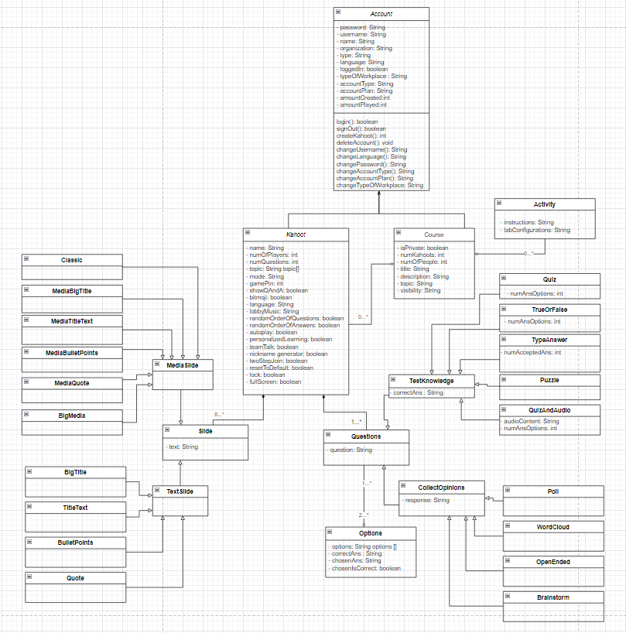

# Justification

<https://drive.google.com/file/d/15HXn3rJ3vhAe1amHFlBSX0kTzePTmbdx/view?usp=sharing>

# Questions

1. Design a 10th type of question.
   1. Describe how it works and why it might be useful. (2)
   2. What attributes would it have? (2)
   3. What is its relationship to the other classes? (2)
   4. Include a diagram of the class. (2)
2. You are tasked to redesign Kahoot to be used in a setting outside of school of your choice. How might the classes change to tailor specifically for that application? Consider changes of relationships/attributes/methods. (2)

1. a) Matching -- drag and drop or draw a string to connect terminology to their definitions or vice versa. This would be beneficial in content with high levels of new terminology to memorize.

b) terms: String terms[], definitions: String definitions []

c) Associated with the other question classes due to the fact that its a question, and more specifically is closer related to the knowledge testing class questions because its a knowledge testing question. Could also have typed answers where you type the term matching with the definition and in that case would be composition with the type answer class. This is because it would now essentially be a group of typed answer questions and would not exist without type answer questions.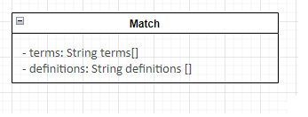

d)

2. With Kahoot being a very thorough quizzing system, it could very easily be applied to other demographics. Companies often require employees to complete a series of trainings every year which tend to be composed of many slideshows. A Kahoot-like application could act as an end-of-slide quiz to solidify their knowledge and help achieve more competent workers. In a more professional setting with an older demographic, it’s likely that more of the childish attributes are removed such as most music options, bitmojis, and a random name generator (which often gives you something like “swaggy walrus”). Other than that the relationships and methods would seem to remain the same.